Excel Project: Data Cleanup

Author: Emily Kokol-Rivera | Date: October 2025 | GitHub: <https://github.com/emilyannKR/excel-portfolio/blob/main/Data%20Cleaning/Data%20Cleaning.xlsx>

# Project Overview

This project used Excel’s Power Query Editor to clean and standardize a messy customer dataset. Tasks included correcting inconsistent capitalization, formatting phone numbers, validating emails, converting mixed date formats, and removing duplicates. The final output was a fully standardized table ready for analysis and reporting.

# Tools & Skills Demonstrated

* Power Query for data transformation
* Data type conversion and locale handling
* Text cleaning and standardization (Trim, Clean, Proper Case, Replace Values)
* Conditional logic and custom columns
* Deduplication and column reordering

# Dashboard Snapshot

Final Cleaned Dataset in Power Query after applying text transformations, format normalization, and deduplication.

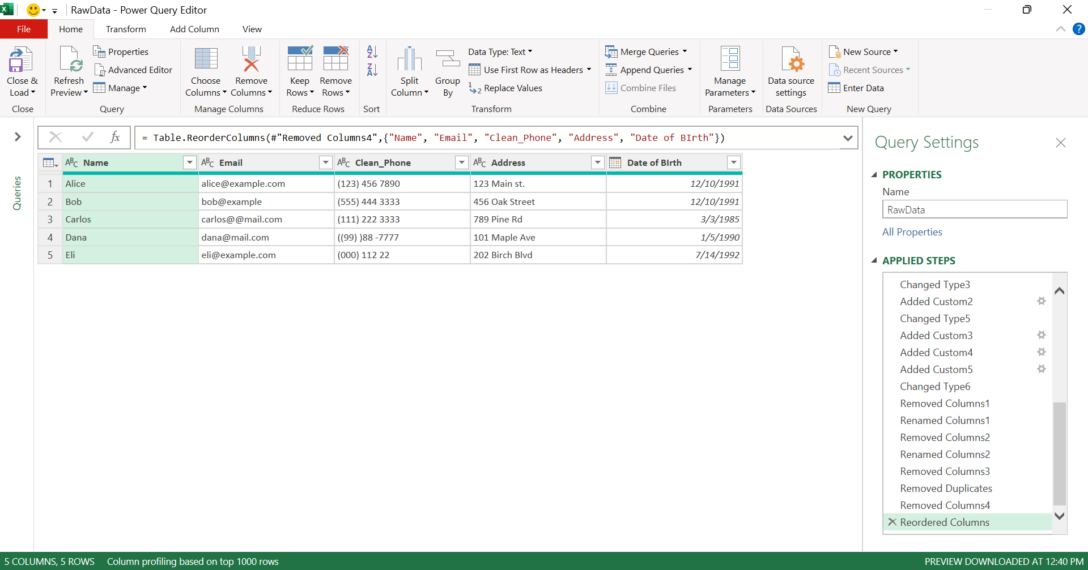

# Key Insights

* Standardized all phone numbers to a consistent format using Power Query transformations.
* Normalized inconsistent date formats using locale-based parsing.
* Removed duplicate customer records based on email to ensure data accuracy.

# Learning Reflection

The cleanliness of the data before starting is important. This issue is seen in the phone numbers for Dana and Eli as well as the email for Bob in the raw data.